**Numerical Evaluation of Maxwell’s Equations**

**Lab 8**

IDName: Niruyan Rakulan Zhiwei Chen

ID:214343438 212654265

**Introduction:**

The purpose of this lab is to solve Faraday’s Law using Matlab, and a self-made function called ‘faraday’. The function receives a ‘x’ and ‘y’ value that correspond to the bounds of a rectangular loop(-x to x, and -y to y), and t(time values for which voltage is to be calculated). The function outputs an array with voltage values for the respective time values.

**Methodology**

It was known that the directions of **B** and the differential area(**dS**) are the same(in z direction), so a scalar of Bds is produced in the double integral. The sin(8*π*t) is taken out of the integral because it is not dependent on x or y.

The approach taken to solve the double integral was to approximate the integral using the midpoint rule; the midpoint was chosen over right, and left-hand side Riemann sum for more accuracy. The x, and y coordinate in which the rectangle loop occupies is split into mxn(m and n are large values like 10000), infinitesimally small rectangles with length of dx, and width of dy(dx=xo-(-xo)/m and dy=yo-(-yo)/n), and the function was evaluated at the midpoints of the rectangles, were summed up, and multiplied with dA(which is equal to dx*dy). dy and dx dynamically changes for different values for x and y; this is to ensure that the amount of time to compute the integral is the same for varying x, and y values, and the Matlab program does not take a long time to finish.

Another methodology for solving the integration was discussed. dx, and dy were initialized to be small values(ex. 0.001). This method is more accurate for large spans because the values of dx, and dy are smaller than what they would be if the first method is chosen. It was noticed however this methodology was inaccurate for small values of x, and y because the values of dx, and dy are greater than the values for the first method(leading to inaccuracy), and this method on average takes a much longer time to complete for larger values of x, and y.

The chosen method(first method) is more accurate for small spans, and more inaccurate for long spans however, the time varied to complete the integral was consistent. In choosing the first method, accuracy for large values of x, and y was sacrificed in favor of accuracy for small values, as well as a consistent completion time .

The derivative was evaluated by using the definition of a limit. h was chosen to be 0.0000001.  
http://tutorial.math.lamar.edu/Classes/CalcI/DefnOfDerivative_files/eq0006M.gifhttp://tutorial.math.lamar.edu/Classes/CalcI/DefnOfDerivative_files/empty.gif

**Results**

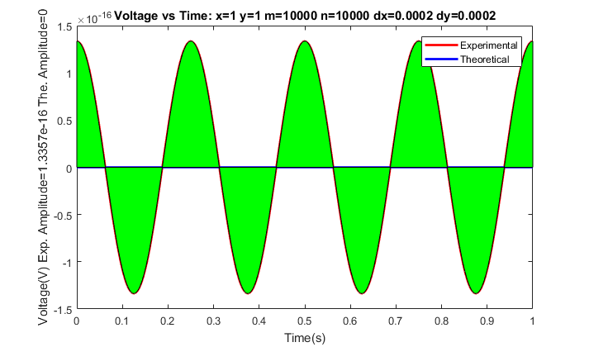

Figure 1a: Shows the values of the voltage when using the self-made function(Experimental), and the actual voltage(Theoretical); green is difference between the values. Theoretically, the value of the voltage is supposed to be zero for when both x, and y are values that are multiples of 0.25(ie 0.25,0.5, 1) since period is 0.5. The value found by the self made function is close to 0(amplitude is less than 1.33x10^-16).

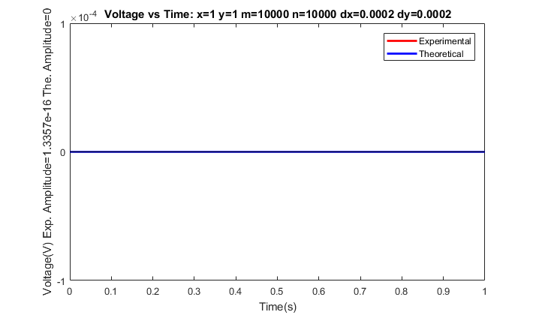

Figure 1b: Shows a better representation of the voltage found experimentally after rescaling the y-axis

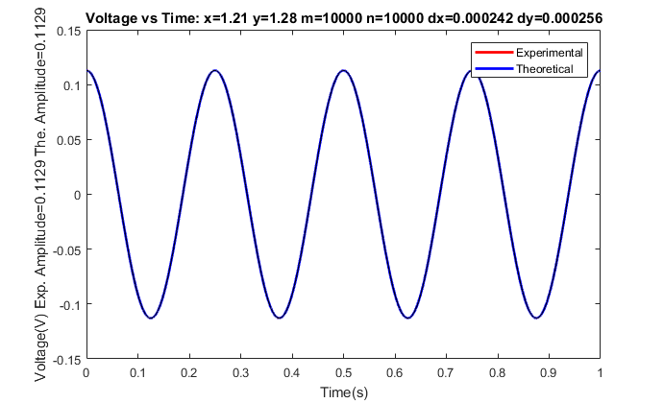

Figure 2: Voltage for when x=1.21, and y=1.28(chosen randomly). The voltages for experimental, and theoretical are almost identical.

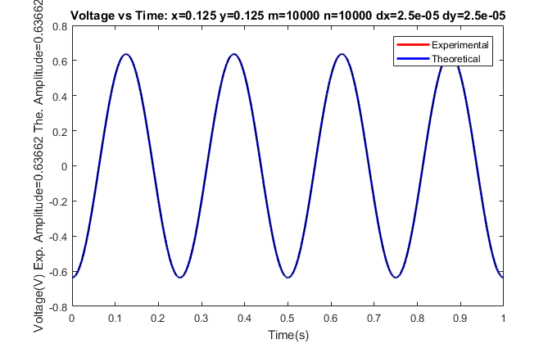

Figure 3a: Max Voltage is around 0.637v for when x=0.125+0.5n, and y=0.125+0.5n(if x, and y allowed to be the same), since periodic with 0.5. The voltages for experimental, and theoretical are almost identical.

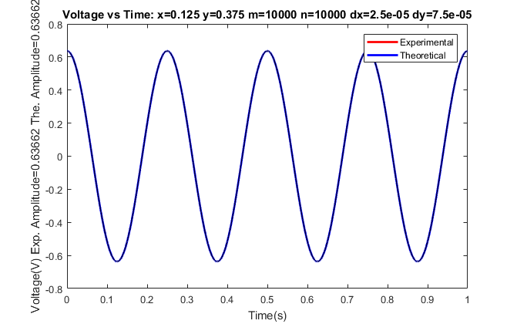

Figure 3b: Max Voltage is around 0.637v for when x=0.125, and y=0.375(if x, and y have to be different). The voltages for experimental, and theoretical are almost identical.

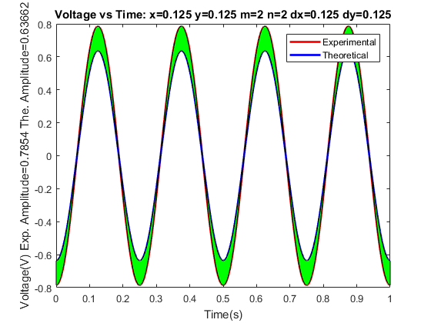

Figure 4a: The difference between the theoretical and experimental voltages when m=2 and n=2, or dx=0.125, and dy=0.125.

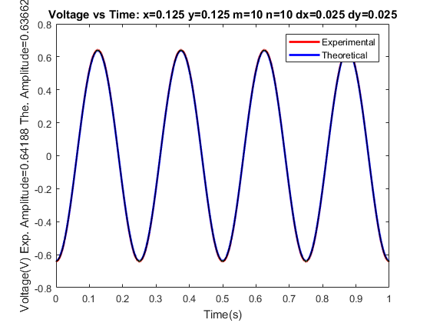

Figure 4b: Voltage values for when m=10 and n=10, or dx=0.025 and dy=0.025. The experimental value is closer to theoretical as supposed to dx=0.125, and dy=0.125.

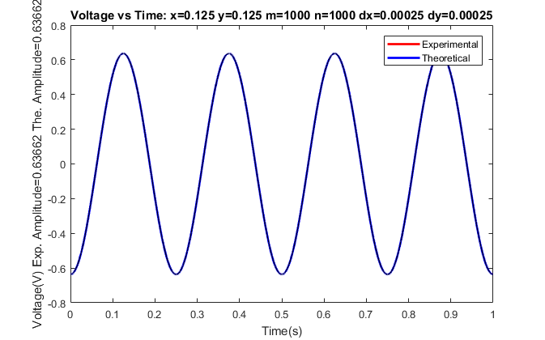

Figure 4c: Voltage values for when m=1000 and n=1000, or dx=0.00025 and dy=0.00025. The experimental value is closer to theoretical as supposed to dx=0.025 and dy=0.025

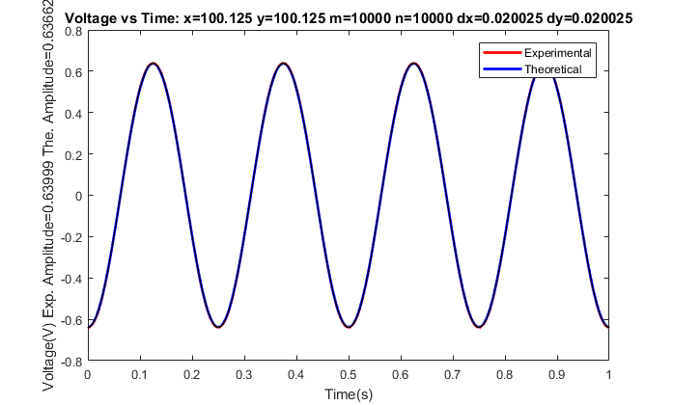

Figure 5a: Method 1 at x=100.125, and y=100.125. This method took less time (around 5 seconds) for this specific surface, however slightly less accurate.

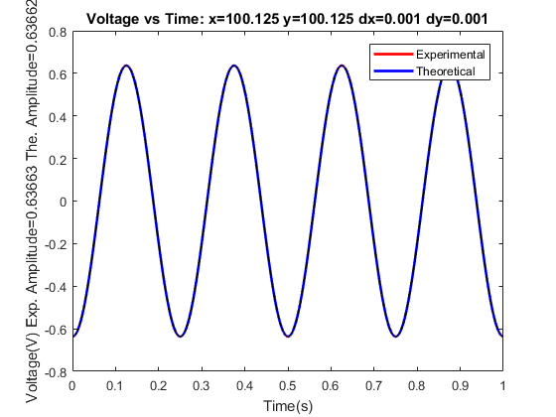

Figure 5b:Method 2 at x=100.125, and y=100.125. This method is more accurate for this specific surface, however takes longer time(around 5 minutes) to complete in Matlab.

**Conclusion:**

It was shown in the lab that if surface was split into smaller rectangles, the answer is more accurate, however, if the points were infinitesimally small, the Matlab program will take much longer to finish. It was also shown the method chosen(Method 1) is better for smaller surfaces and generally has a quicker time of completion, however is more inaccurate at larger surfaces in comparison to the other method.

References:

<https://www.youtube.com/watch?v=9AA91hpNHno>

<http://tutorial.math.lamar.edu/Classes/CalcI/DefnOfDerivative.aspx>